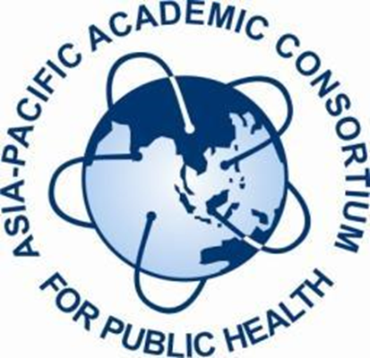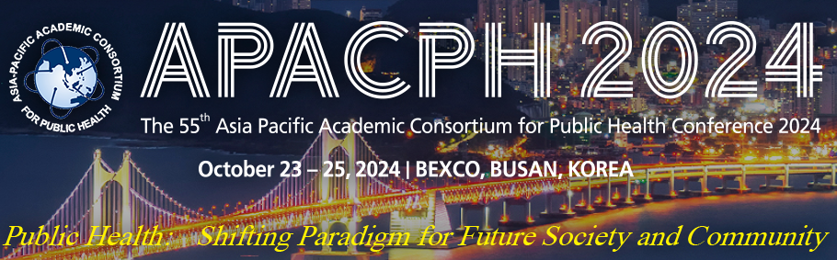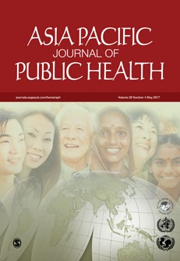

APACPH 2024 POST-CONFERENCE WORKSHOP

WRITING A PUBLIC HEALTH PAPER AND JOURNAL MANAGEMENT

Date: 26th October 2024 (Saturday)
Time: 10:00 am – 5:00 pm
Venue: Centum Premier Hotel, Busan

Workshop Summary:

This workshop is organized by the Asia-Pacific Journal of Public Health (APJPH) in conjunction with the 55th Asia-Pacific Academic Consortium for Public Health (APACPH) Conference. The aim of this workshop is to meet individual and institutional needs to enhance research and acquire comprehensive knowledge and skills to write and publish a quality scientific manuscript. There will be an emphasis on the common errors made in undertaking research and presenting it in a way that editors will accept your paper for publication. We will provide an outline of an academic article and examples of common errors in the workbook provided to attendees. We will also share an overview of running a public health journal and the roles and responsibilities of journal editors. The workshop will also include an introduction to journal indexing. Major indexing services like PubMed, Journal Citation Reports (Impact Factors), and Scopus (CiteScore) will be addressed. For articles that are published, we will also provide information on the different types of article metrics available to assess the impact of your work, such as downloads and citations. Publication ethics is an important topic in scientific publishing, and we will be sharing on tackling conflicts of interest, authorship issues, data fabrication, plagiarism, and other misconducts. The target for the workshop is public health students, researchers, academic staff, journal editors, and reviewers who conduct research and need to develop successful scientific writing skills.

Workshop notes and Certificate of Attendance will be given to all participants.

Program:

Title : Writing a Public Health Paper and Journal Management
Date : 26th October 2024 (Saturday)
Time : 10:00 am – 5:00 pm
Venue : Centum Premier Hotel, Busan
Target Audience : Authors, Reviewers, Editors, Researchers, Journal Staff, Academics, Students

 | Time | Duration | Proposed Topic | Speaker | Main Target Audience
 | 9:45 – 10:00am | 15 mins | Registration
 | 10:00 – 10:10am | 10 mins | Welcome speech and Introduction to APJPH | Prof. Dr. Wah Yun Low
1 | 10:10 – 11:10am | 1 hour | Writing and Publishing a Public Health Paper | Prof. Colin Binns | Open to ALL  (Mainly Authors)
1 | 11:10 – 11:20am | 10 mins | Short break | Prof. Colin Binns | Open to ALL  (Mainly Authors)
1 | 11:20 – 12:20pm | 1 hour | Cont: Writing and Publishing a Public Health Paper | Prof. Colin Binns | Open to ALL  (Mainly Authors)
1 | 12:20 – 12:40pm | 20 mins | Q & A Session (Moderator: Tee Guat Hiong) | Prof. Colin Binns | Open to ALL  (Mainly Authors)
 | 12:40 – 2:00 pm | 1 hour 20 mins | Lunch break
2 | 2:00 – 2:30pm | 30 mins | Running a Public Health Journal and Peer Review | Prof. Dr. Wah Yun Low | Open to ALL  (Mainly Editors)
3 | 2:30 – 3:00pm | 30 mins | Roles and Responsibilities of Editors | Prof. Dr. Wah Yun Low | Open to ALL  (Mainly Editors)
 | 3:00 – 3:10 pm | 10 mins | Short break
4 | 3:10 – 3:40 pm | 30 mins | Journal Indexing | Bairave Shunnmugam | Open to ALL
5 | 3:40 – 4:10pm | 30 mins | Publication Ethics | Prof. Dr. Wah Yun Low | Open to ALL
 | 4:10 – 4:40pm | 30 mins | Discussion and Q & A Session (Moderator: Bairave Shunnmugam)
 | 4:40 - 5:00pm | 20 mins | Closing and Photography session
 | 5:00pm |  | Workshop ends

About the speakers:

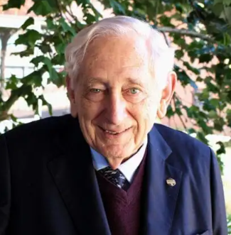
Emeritus Professor Dr. Colin Binns
MBBS (UWA), MPH (Harvard), PhD (Inje), FRACGP, FAFOEM, FAFPHM

Professor Binns graduated in medicine from the University of Western Australia and worked in hospitals in Perth and then for eight years in Papua New Guinea (PNG). In PNG, he became very interested in nutrition and received a scholarship to complete an MPH degree at Harvard. He returned to Australia to Curtin University and was appointed as the Foundation Head of the School of Public Health, a position he held for 21 years. He was the Vice-President of the Asia Pacific Academic Consortium for Public Health (APACPH) for five years and is now an Editor of the Asia-Pacific Journal of Public Health (APJPH). He holds visiting professorial positions at the Kagawa Nutrition University, Tokyo and University of Ryukus, Okinawa in Japan; Tonji Medical College, Wuhan and Changsha Children’s Hospital, PR China; Taipei Medical University, Taiwan; and Inje University, South Korea. He has served on 17 committees of the National Health and Medical Research Council, including Chair of the Dietary Guidelines Committees for infants, children, adults, and elderly Australians. He remains a member of the Australian Dietary Guidelines Committee and has published more than 600 scientific articles and book chapters. Some Honours he has received include the ‘Officer of the Order of Australia (AO), Senior Western Australian of the Year’, an honorary PhD from Inje University, Korea, Research Australia Lifetime Achievement Award for medical research in Australia, and the Asia- Pacific Clinical Nutrition Award 2012 for contributions to nutrition in the Asia-Pacific region.
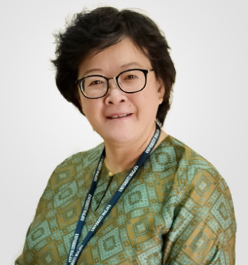
Prof. Dr. Wah Yun LOW
PhD, AFBPsS, FBSCH, CPsychol., FASc
Prof Low is the Editor-in-Chief of the Asia-Pacific Journal of Public Health (APJPH) and the President Emeritus of APACPH. She is Honorary Professor of the Faculty of Medicine, Universiti Malaya, Malaysia. She graduated with a BA (Hons) from the Universiti Kebangsaan Malaysia and subsequently obtained her MSc and PhD from the University of Surrey, Guildford, England. Professor Low is actively engaged in teaching, research, service, and consultancy. She has published more than 30 books and book chapters and over 300 publications in peer-reviewed journals, particularly in the areas of behavioral science, sexual and reproductive health, HIV/AIDS, men’s health, and aging. She serves on several editorial boards of journals, and members of many learned societies. She is a Fellow, Academy of Sciences Malaysia. Prof Low is the co-author of the book “Writing and Publishing a Public Health Research Paper”, published by the University of Malaya Press, Kuala Lumpur.

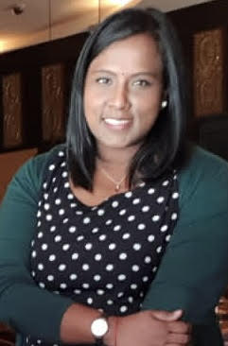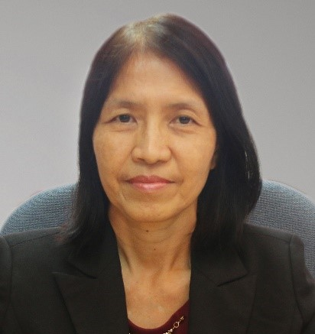
Bairave Shunnmugam Tee Guat Hiong
BBioMedSc (Hons), MMedSc BBioMedSc (Hons), MMedSc(PH)

